

Topic test 2
Name: __________________________________

Chapter 9: Derivatives

- Time allowed: 45 minutes
- CAS calculators may be used.
- Part A: 5 multiple-choice questions (5 marks)
- Part B: 6 short answer questions (20 marks)
- Part C: 2 analysis questions (12 marks)
Part A
5 multiple-choice questions
1 mark each: 5 marks
Circle the correct answer.
1 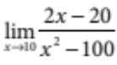 =
A 0
B 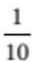
C
D 2
E none of the above
[1 mark]
2 The gradient of the curve with equation y  f(x) at the point (a, f (a)) is given by:
A 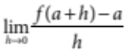
B 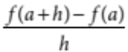
C 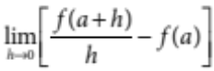
D 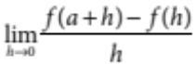
E 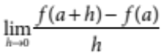

[1 mark]
3 If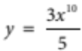 then 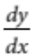 is equal to:
A 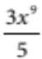
B 30x9
C 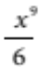
D 6x9
E 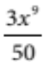
[1 mark]
4 The equation of the tangent to y  ax2 at the point (2a, 4a3) is
A y  2ax + 4a3
B y  2ax  a2
C y  3ax  8a2
D y  2a2x + 4a2
E y  4a2x  4a3
[1 mark]
5 The displacement–time graph of an object moving in a straight line over 4 minutes is shown below.
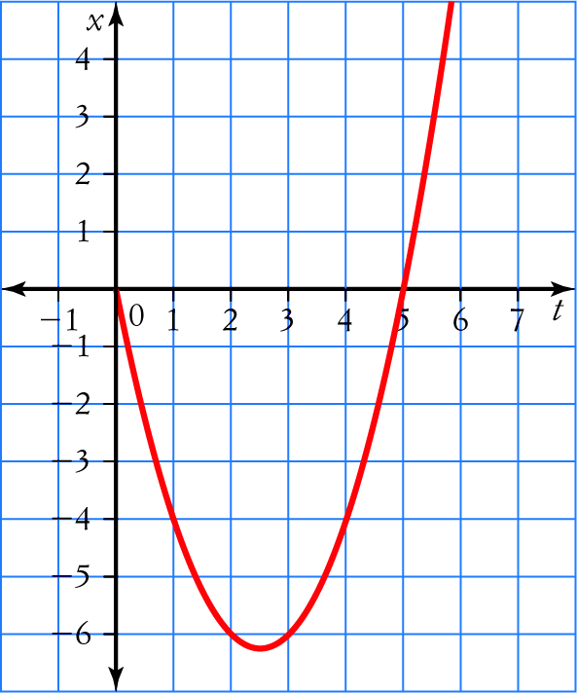
The velocity of the object is best described as:
A always positive
B initially negative, then changing to positive, then changing back to negative
C initially negative, then changing to and remaining positive
D initially positive, then changing to negative, then changing back to positive
E initially positive, then changing to and remaining negative.
[1 mark]
Part B
6 short answer questions
20 marks
Show your working where appropriate.
1 For the function f(x)  5x2  8x  1:
a find f(1)

b find f(1  h)

c find the gradient of the secant between the point where x  1 and x  1  h

d hence, choose appropriate values for h to find f °(1).

[4 marks]
2 Using first principles, find the derivative of f(x)  2x2

[3 marks]
3 By first considering the chord joining the points P(x, y) and Q(x  h, y  k), find the gradient of the curve
y  2x3 at x  1.

[4 marks]
4 A particle moves so that its distance (in cm) from a fixed point is given by 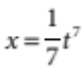, where t is the time in seconds. Find its velocity after 2s.

[2 marks]
5 Find the equation of the tangent to the curve f(x)  2x3 at the point (2, 16).

[4 marks]
6 A candle burns with a steady flame and gradually diminishes. The height of the candle in cm after burning for t seconds is given by the rule 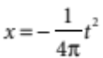
Find the exact speed at which the height of the candle is decreasing after it has been alight for 3 seconds.

[3 marks]

Part C
2 analysis questions
12 marks
Show your working where appropriate.
1 The position of a pebble thrown into the Yarra river is given by x  7t2, where x is in metres and t is in seconds.
a Draw a graph showing the height from 0 secs to 2 secs in 0.2 intervals.


b Calculate the speed, 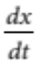, of the pebble.

c Draw a graph of the speed of the pebble from 0 secs to 2 secs.

d Calculate the average speed from 0 secs to 2 secs.

e Compare the average speed to the instantaneous speed.

[6 marks]

2 The cost of producing 60 ovens is given by:
C(x)  0.04x3, where the cost, C(x), of producing x ovens is given in dollars.
a Find the cost of producing 60 ovens.

b Find the average cost of producing each oven if 60 ovens are made.

c Find the marginal cost of producing an extra oven over 60 ovens.
d Compare the average and marginal costs at:
i 60 ovens

ii 100 ovens

iii 130 ovens.

[6 marks]
Total marks: 37

Answers
Part A [1 mark each]
1 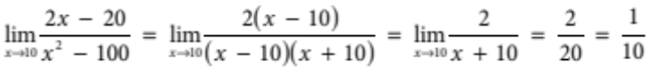
 B [1 mark]
2 Replace x in 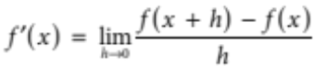 with a.
 E [1 mark]
3 Using the rule for finding the derivative of a polynomial:
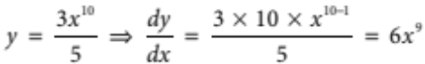
 D [1 mark]
4 The derivative of the function is 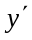 2ax. At the point (2a, 4a3), the tangent has gradient 4a2. The equation of the tangent in point slope form is:
y  4a3  4a2(x  2a)
y  4a2x  8a3  4a3
 4a2x  4a3
 E [1 mark]
5 From 0 to about 2.5 seconds, the gradient of the graph is negative. The gradient is 0 where the graph turns, and after that it becomes positive.
 C [1 mark]
Part B
1 a f(1)  5(1)2  8(1)  1  2 [1 mark]
b f(1  h)  5(1  h)2  8(1  h)  1
 5(1  2h  h2)  8  8h  1
 5  10h  5h2  8  8h  1
 5h2  2h  2 [1 mark]
c 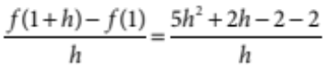
 5h 1 2 [1 mark]
d 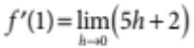
 2 [1 mark]

2 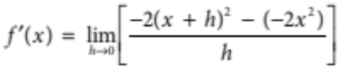 [1 mark]
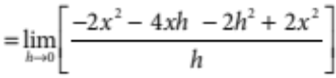 [1 mark]
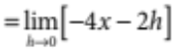
 4x [1 mark]
3 Slope of chord 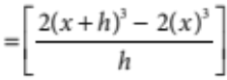
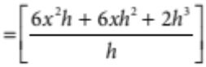 [1 mark]
 6x2  6xh  2h [1 mark]
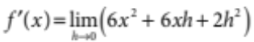
 6x2 [1 mark]
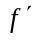(1)  6 [1 mark]
4 v  t6 [1 mark]
For t  2, v  (2)6  64 cm/s [1 mark]
5 (x)  6(x)2 [1 mark]
(2)  6(2)2  24 [1 mark]
Using (2, 16) and m  24 in y  mx  c
16  24  2  c [1 mark]
So c  32.
y  24x  32 [1 mark]
6 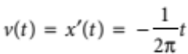 [1 mark]
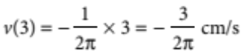 [1 mark]
The height is decreasing at a speed of 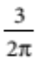 cm/s. [1 mark]
Part C
1 a 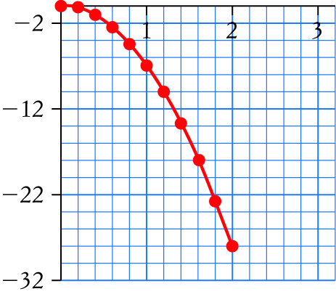
[1 mark]
b 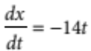 [1 mark]
c 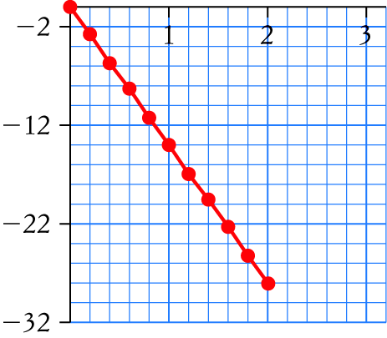
[1 mark]
d Average speed 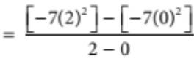 [1 mark]
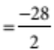 [1 mark]
 14 m/s [1 mark]
e The average speed is the average of the instantaneous speeds. [1 mark]
2 a C (60)  0.04(60)3  $8640 [1 mark]
b 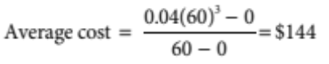 [1 mark]
c 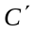(x)  0.12(60)2  $432 [1 mark]
d i The average cost ($144) is lower than the marginal cost ($432).
ii The average cost ($400) is lower than the marginal cost ($1200).
iii The average cost ($676) is lower than the marginal cost ($2028).

